**GROUP ASSIGNMENT**

**(GROUP WORK)**

**CT043-3-1-IN**

**INTRODUCTION TO NETWORKING**

**HAND OUT DATE: 09 OCTOBER 2023**

**HAND IN DATE: 12 JANUARY 2024**

**WEIGHTAGE: 50%**

**________________________________________________________**

**Group Members:**

|  |  |
| --- | --- |
| **Name** | **TP Number** |
| **Ng Zhe Shen** | **TP071625** |
| **Png Zhee Qian** | **TP070287** |
| **Goh Yuan Kee** | **TP070126** |
| **Chloe Tan Jia Xin** | **TP070759** |

**Lecturer: Mr. Joshua Samual**

# Work Breakdown Structure

|  |  |  |
| --- | --- | --- |
| Name | Task | Signature |
| Ng Zhe Shen | * New Zealand branch * Conclusion |  |
| Png Zhee Qian | * Japan branch | 查看照片 |
| Goh Yuan Kee | * USA branch |  |
| Chloe Tan Jia Xin | * Australia branch |  |

Table of Contents

Work Breakdown Structure 2

Student 1: Ng Zhe Shen TP071625 (New Zealand) 4

Student 2: Png Zhee Qian TP070287 (Japan) 6

Student 3: Goh Yuan Kee TP070126 (USA) 9

Student 4: Chloe Tan Jia Xin TP070759 (Australia) 14

Network Device Configuration Techniques 17

Conclusion 29

References 30

# Student 1: Ng Zhe Shen TP071625 (New Zealand)

Network Topology Design and Justification:

SuperByte’s New Zealand branch implemented star topology as its network architecture. The switch will take the role of central node in each department, while the router behaves as the central node for the whole LAN in the branch of New Zealand. The central node will relay the data sent from one of its end-devices to the intended destination. The methods used by the network layer protocol, in this case IPv4, to forward data include unicast, broadcast, and multicast. The implementation of star topology in New Zealand LAN offers great scalability, meaning new devices or new departments can be added into the network anytime without affecting other already existing devices. New connections can be established by simply adding additional connections to the switch or router. Furthermore, star topology provides stable and consistent performance in terms of network traffic management. Every dedicated connection ensures that no data collision can happen and avoid network congestion.

IP Addressing Scheme and Subnet Table:

Subnet Table (New Zealand branch):

|  |  |  |  |  |  |  |
| --- | --- | --- | --- | --- | --- | --- |
| Department | No. of Hosts | Subnet Mask Value | Network ID | First Valid IP | Last Valid IP | Broadcast IP |
| IT | 11 | 255.255.255.240 | 172.16.0.0 | 172.16.0.1 | 172.16.0.14 | 172.16.0.15 |
| R&D | 8 | 255.255.255.240 | 172.16.1.0 | 172.16.1.1 | 172.16.1.14 | 172.16.1.15 |
| Pantry | 5 | 255.255.255.248 | 172.16.2.0 | 172.16.2.1 | 172.16.2.6 | 172.16.2.7 |
| HR | 7 | 255.255.255.240 | 172.16.3.0 | 172.16.3.1 | 172.16.3.14 | 172.16.3.15 |
| Finance | 9 | 255.255.255.240 | 172.16.4.0 | 172.16.4.1 | 172.16.4.14 | 172.16.4.15 |
| Meeting rooms | 11 | 255.255.255.240 | 172.16.5.0 | 172.16.5.1 | 172.16.5.14 | 172.16.5.15 |

SuperByte has a Class B network 172.16.0.0/16 and has divided it into 4 subnets, with the New Zealand branch taking the subnet of 172.16.0.0/18 until 172.16.63.255/18. This subnet is able to host a total of 16382 end-devices. However, the number of host machines under the New Zealand branch currently are far less than the available IP addresses, which might result in waste of IP addresses. Thus, VLSM is performed to further subnetting the network into multiple smaller subnets according to the actual number of end-devices in each department.

The IP address range of 172.16.0.0/28 to 172.16.0.15/28, which can accommodate a maximum of 14 hosts is allocated to IT department that contains 11 hosts.

The R&D department is given the IP address range of 172.16.1.0/28 to 172.16.1.15/28 to host the 8 end-devices, with 6 spare valid IP addresses unused.

Due to the small volume of IP addresses required, the pantry that has only 5 end-devices gets the IP address range of 172.16.2.0/29 to 172.16.2.7/29.

The IP address range of 172.16.3.0/28 to 172.16.3.15/28 is used by the HR department to host its 7 end-devices, leaving room for potential additional devices in the future.

For the finance department that contains a total of 9 end-devices, the IP address range of 172.16.4.0/28 to 172.16.4.15/28 is given as it is the small possible subnet in this case.

Finally, the IP address range of 172.16.5.0/28 to 172.16.5.15/28 is allocated for the meeting rooms that bears 11 hosts to minimize address wastage.

# Student 2: Png Zhee Qian TP070287 (Japan)

Network Topology design and Justification:

The topology design used for the Japan’s Office Branch is the star topology design. The switches in each department will serve their purpose as the central hub that manages the flow of data between devices and the router will then be the central hub for all the switches and it is the central hub for Japan’s Office Branch. With this centralized topology it is much easier to track down and troubleshoot the network problems.

One of the reasons I chose this topology is because it is easy to use. It is quite easy to add or remove switches using this topology and this makes modifications to the network topology more convenient. Other than that, it is also much more reliable because even if one node malfunctions, it won’t affect the other nodes.

IP Addressing Scheme and Subnet Table:

Subnet Table (Japan branch):

|  |  |  |  |  |  |  |
| --- | --- | --- | --- | --- | --- | --- |
| Department | No. of Hosts | Subnet Mask Value | Network ID | First Valid IP | Last Valid IP | Broadcast IP |
| IT | 15 | 255.255.255.224 | 172.16.64.0 | 172.16.64.1 | 172.16.64.30 | 172.16.64.31 |
| Finance and accounting | 14 | 255.255.255.240 | 172.16.65.0 | 172.16.65.1 | 172.16.65.14 | 172.16.65.15 |
| Sales and Marketing | 14 | 255.255.255.240 | 172.16.66.0 | 172.16.66.1 | 172.16.66.14 | 172.16.66.15 |
| HR | 6 | 255.255.255.240 | 172.16.67.0 | 172.16.67.1 | 172.16.67.14 | 172.16.67.15 |
| Customer service | 5 | 255.255.255.248 | 172.16.68.0 | 172.16.68.1 | 172.16.68.6 | 172.16.68.7 |

SuperByte has a Class B network 172.16.0.0/16 and has divided it into 4 subnets, with the Japan branch taking the subnet of 172.16.64.0/18 until 172.16.127.255/18. This subnet is able to host a total of 16382 end-devices. This will result in a large amount of empty IP addresses because the branch here in Japan isn’t very big yet and doesn’t need that much. There is also a good sign where when there are new departments or when it needs upgrading, there are plenty of IP addresses to give out to the end devices. For now, the Japan branch has set VLSM to do further subnetting for each department with enough end devices to get their respective IP address.

For the largest department, which is the IT department, the network ID has been set to 172.16.64.0 and the subnet mask value is 255.255.255.224, the range for it starts from 172.16.64.1 to 172.16.64.30 and only 15 hosts have been used.

Moving on will be the Finance and accounting department, the network ID has been set to 172.16.65.0 and the subnet mask value is 255.255.255.240, the range for it starts from 172.16.65.1 to 172.16.65.14 and only 12 hosts have been used.

Moving on will be the Sales and marketing department, the network ID has been set to 172.16.66.0 and the subnet mask value is 255.255.255.240, the range for it starts from 172.16.66.1 to 172.16.66.14 and only 12 hosts have been used.

Moving on will be the HR department, the network ID has been set to 172.16.67.0 and the subnet mask value is 255.255.255.240, the range for it starts from 172.16.67.1 to 172.16.67.14 and only 6 hosts have been used.

Moving on will be the Customer Service department, the network ID has been set to 172.16.68.0 and the subnet mask value is 255.255.255.248, the range for it starts from 172.16.68.1 to 172.16.68.6 and only 4 hosts have been used.

# Student 3: Goh Yuan Kee TP070126 (USA)

**Star topology:**

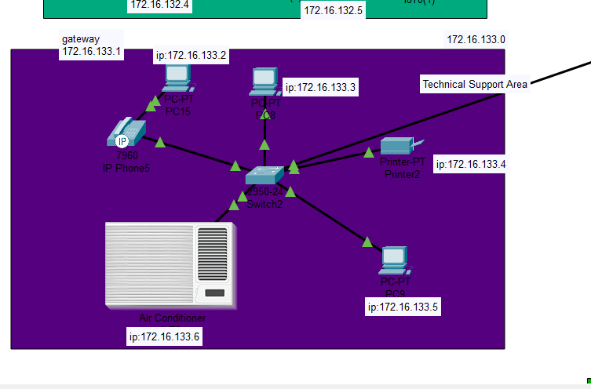

Star topology is a network setup where all devices link to a central hub or switch. This straightforward design simplifies installation, troubleshooting, and expansion, offering easy scalability. Issues with individual devices or cables have localized impacts, minimizing network disruptions.

**Advantages of star topology:**

Easy Troubleshooting:

Troubleshooting is simplified as each device has a direct connection to the central hub, making it straightforward to identify and resolve issues promptly.

Scalability:

Star topology allows for the easy addition of more devices to the central hub, making it highly scalable and adaptable to expanding network needs.

Isolation of Devices:

Failures in one device do not impact others in the network, ensuring the stability of the overall system. This isolation feature enhances the reliability of the network.

**Why choose star topology:**

Simple Implementation:

Star topology is preferred for its straightforward setup, ideal for beginners or scenarios demanding a quick and uncomplicated network arrangement.

Easy Cable Management:

The design of star topology simplifies cable organization, aiding in the swift identification and replacement of faulty cables. This reduces the likelihood of confusion in managing cables.

Centralized Hub:

The central hub or switch serves as a focal point, streamlining network management, troubleshooting, and configurations. This centralized control boosts overall network efficiency.

In USA LAN, star topology is used on Customer Service Area, Server room, Manager's office, Meeting room, Technical Support Area, Print/Copy Room, Quiet/Concentration Rooms and Common Area (Lounge).

**Bus Topology:**

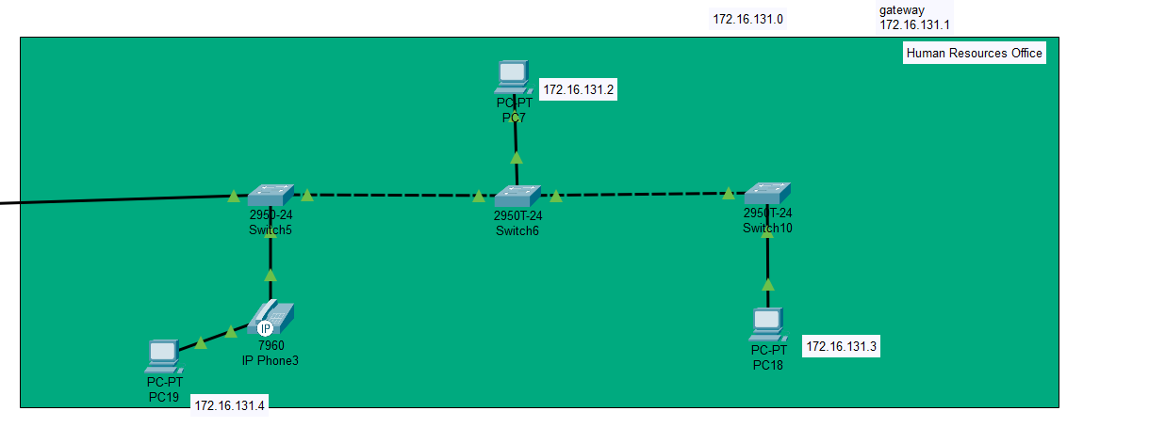

Bus topology is a network configuration where all devices share a single communication line. In this setup, a main cable, called the bus, connects all devices on the network. Each device can access and send data on the bus, and the data reaches only the intended recipient.

**Advantages of Bus Topology:**

Simplicity:  
 Bus topology is straightforward to set up as all devices share a single communication line, reducing the complexity of network configuration. Additionally, it requires less cabling, making it a cost-effective solution for small to medium-sized networks.

Cost-Effective:

Bus topology is budget-friendly due to its minimal cabling requirements. The single bus cable reduces the overall cost of network infrastructure, especially beneficial for organizations with financial constraints.

Ease of Expansion:

Expanding the network by adding new devices is relatively easy in bus topology. Devices can be connected to the central bus without major disruptions, providing flexibility for network growth.

**Why Choose Bus Topology:**

Simple Networks:

Bus topology is suitable for small networks with a limited number of devices.

Budget Constraints:

When cost is a significant factor, bus topology offers a cost-effective solution.

Ease of Installation:

Quick and straightforward setup makes bus topology suitable for temporary or small-scale networks.

In summary, bus topology is a basic and economical choice for smaller networks where simplicity and ease of setup outweigh potential limitations. Bus topology is used on Human Resources Office.

|  |  |  |  |  |  |  |
| --- | --- | --- | --- | --- | --- | --- |
| **Dept** | **No of host** | **Network id** | **Subnet Mask** | **First Valid IP** | **Last Valid IP** | **Broadcast IP** |
| Customer Service Area | 5 | 172.16.128.0 | 255.255.255.248 | 172.16.128.1 | 172.16.128.6 | 172.16.128.7 |
| Server room | 3 | 172.16.129.0 | 255.255.255.252 | 172.16.129.1 | 172.16.129.4 | 172.16.129.5 |
| Manager's office | 4 | 172.16.130.0 | 255.255.255.252 | 172.16.130.1 | 172.16.130.5 | 172.16.130.6 |
| Human Resources Office | 3 | 172.16.131.0 | 255.255.255.252 | 172.16.131.1 | 172.16.131.4 | 172.16.131.5 |
| Meeting room | 5 | 172.16.132.0 | 255.255.255.248 | 172.16.132.1 | 172.16.132.6 | 172.16.132.7 |
| Technical Support Area | 5 | 172.16.133.0 | 255.255.255.248 | 172.16.133.1 | 172.16.133.6 | 172.16.133.7 |
| Print/Copy Room | 7 | 172.16.134.0 | 255.255.255.248 | 172.16.134.1 | 172.16.134.8 | 172.16.134.9 |

The IP address allocation within the office building in the United States is a strategic and meticulous process, tailored to meet the unique communication and network management needs of various functional areas. This thoughtful approach involves assigning dedicated IP address ranges to specific departments, fostering a network infrastructure that ensures seamless connectivity, distinct management, and optimized performance based on the specific requirements of each workspace.

Consider, for instance, the Customer Service Area, a crucial hub for client interaction. This department is assigned the IP address range 172.16.128.0, a subnet carefully chosen to accommodate the anticipated volume of end devices, such as computers and phones, within this bustling space. The subnetting design is critical here, as it not only provides a unique identity to the Customer Service Area but also streamlines network management, facilitating efficient troubleshooting and resource allocation.

Moving to the Technical Support Area, the IP address range 172.16.133.0 has been allocated, establishing a distinct subnet for the technical support operations. This decision is rooted in the need for a segregated network space to facilitate troubleshooting processes, software updates, and communication within the Technical Support department. The careful consideration of subnetting allows for clear delineation of network segments, minimizing the risk of interference or congestion from other departments.

The IP addressing scheme extends to other functional areas like the Server Room, Manager's Office, Human Resources Office, Meeting Room, Print/Copy Room, and Quiet/Concentration Rooms, with each receiving a designated IP address range. This comprehensive network design ensures that the office building's network infrastructure is finely tuned to the specific demands of each department, promoting not only connectivity but also security, efficiency, and adaptability in an ever-evolving office environment.

# Student 4: Chloe Tan Jia Xin TP070759 (Australia)

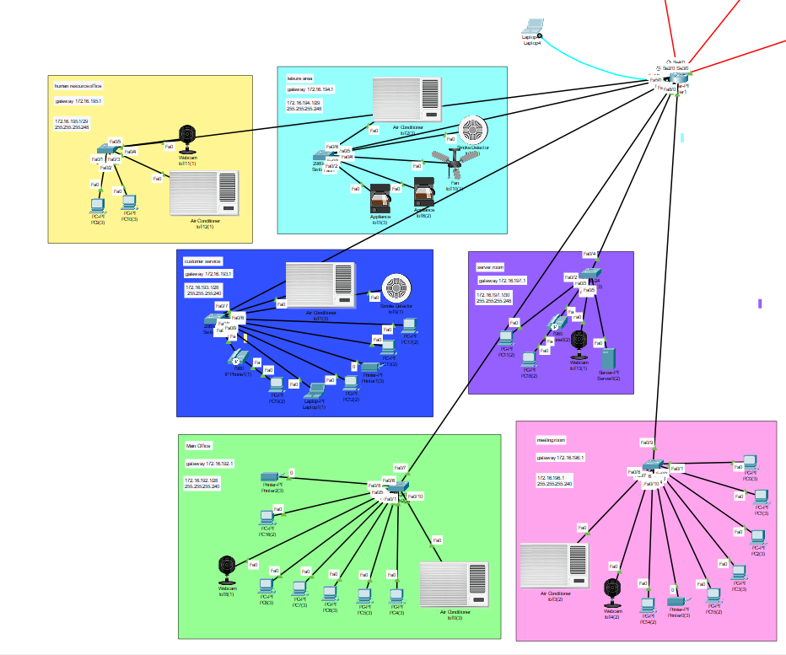

In Australia Office Branch's network structure, the star topology design is utilized. The central components used includes of one router, which serves as the gateway to the internet, and 6 switches for each department, functioning as a hub for end devices. This structure allows devices to communicate effectively and network efficiency.

The star topology comes with many advantages.

* Centralized control

All devices connect to a central point such as the router or switch, allowing it to be easier to solve any troubleshooting problems. Maintenance would be simple, and it would be easier to identify any issues within the network.

* Flexible Cable Management

All devices are directly connected to a central device, making it simple to organize the cables. This setup minimizes the amount of cables needed compared to other topologies, resulting in simpler installations and maintenance.

* Scalability

A star network would be easier to expand just by adding more devices. New devices can be easily added by connecting it to the central point without affecting the current network setup, making it straightforward and easy to grow the network.

|  |  |  |  |  |  |  |
| --- | --- | --- | --- | --- | --- | --- |
| Department | No. of Hosts | Subnet Mask Value | Network IP | First Valid IP | Last Valid IP | Broadcast IP |
| Main Office | 9 | 255.255.255.240 | 172.16.192.0 | 172.16.192.1 | 172.16.192.14 | 172.16.192.15 |
| Customer Services | 9 | 255.255.255.240 | 172.16.193.0 | 172.16.193.1 | 172.16.193.14 | 172.16.193.15 |
| Leisure Area | 5 | 255.255.255.248 | 172.16.194.0 | 172.16.194.1 | 172.16.194.6 | 172.16.194.7 |
| HR Office | 4 | 255.255.255.248 | 172.16.195.0 | 172.16.195.1 | 172.16.195.6 | 172.16.195.7 |
| Meeting Room | 9 | 255.255.255.240 | 172.16.196.0 | 172.16.196.1 | 172.16.196.14 | 172.16.196.15 |
| Server Room | 5 | 255.255.255.248 | 172.16.197.0 | 172.16.197.1 | 172.16.197.6 | 172.16.197.7 |

SuperByte has a Class B network 172.16.0.0/16 and has divided it into 4 subnets, with Australia branch taking the subnet of 172.16.192.0/18 to 172.16.255.255/18. This subnet table is able to host a total of 16382 end devices. Although there is an excessive amount of unused IP addresses, it would be useful if there were any new devices to combine with the current network structure. Therefore, VLSM is performed in order to do further subnetting for every department according to the amount of end-devices there are.

For the Main Office, there are 9 hosts used in this department, and the network IP set is 172.16.192.0. The IP range for it starts from 172.16.192.1 to 172.16.192.14 with a subnet mask value of 255.255.255.240.

Other than that, the total number of hosts used in the Customer Service Department is 9 and the network IP is set to 172.16.193.0. The IP range for it starts from 172.16.193.1 to 172.16.193.14 with a subnet mask value of 255.255.255.240.

In addition, the Leisure Area consists of only 5 hosts and has the network IP set to 172.16.194.0. The IP range for it starts from 172.16.194.1 to 172.16.194.6 with a subnet mask value of 255.255.255.248.

Moving on to the smallest department of the building, which is the Human Resources Office, consists of only 4 hosts and the network IP is set to 172.16.195.0. The IP range for it starts from 172.16.195.1 to 172.16.195.6 and has a subnet mask value of 255.255.255.248.

Following the meeting room, which has 9 hosts and the network IP set to 172.16.196.0. The IP range for it starts from 172.16.196.1 to 172.16.196.14 and has a subnet mask value of 255.255.255.240.

Lastly, the server room consists of 5 hosts and has the network IP set to 172.16.197.0. The IP range for it starts from 172.16.197.1 to 172.16.197.6 and has a subnet mask value of 255.255.255.248.

# Network Device Configuration Techniques

|  |  |
| --- | --- |
|  | Dynamic routing commands to introduce New Zealand networks in Japan router. |
|  | Dynamic routing commands to introduce USA networks in Japan router. |
|  | Dynamic routing commands to introduce Australia networks in Japan router. |
|  | Dynamic routing commands to introduce Japan networks in USA router. |
|  | Dynamic routing commands to introduce New Zealand networks in USA router. |
|  | Dynamic routing commands to introduce Australia networks in USA router. |
|  | Dynamic routing commands to introduce Japan networks in New Zealand router. |
|  | Dynamic routing commands to introduce USA networks in New Zealand router. |
|  | Dynamic routing commands to introduce Australia networks in New Zealand router. |
|  | Dynamic routing commands to introduce New Zealand networks in Australia router. |
|  | Dynamic routing commands to introduce Japan networks in Australia router. |
|  | Dynamic routing commands to introduce USA networks in Australia router. |
|  | Static routing commands to introduce Australia network into New Zealand router. |
|  |  |
|  | Configure router |
|  | Configure static router |
|  | Static routing done to introduce New Zealand network to Japan network. |
|  | Static routing done to introduce USA network to Japan network. |
|  | Static routing done to introduce Australia network to Japan network. |
|  | Air conditioners (AC)configure step |
|  | IP phone |
|  | Webcam configure step |
|  | Smoke Detector configure step |
|  | Server pool configuration for IT department in New Zealand branch. |
|  | Server pool configuration for R&D department in New Zealand branch. |
|  | Server pool configuration for pantry in New Zealand branch. |
|  | Server pool configuration for HR department in New Zealand branch. |
|  | Server pool configuration for finance department in New Zealand branch. |
|  | Server pool configuration for meeting rooms in New Zealand branch. |
|  | Server pool configuration for IT department in Japan Branch. |
|  | Server pool configuration for Finance and Accounting department in Japan Branch. |
|  | Server pool configuration for Sales and Marketing department in Japan Branch. |
|  | Server pool configuration for HR department in Japan Branch |
|  | Server pool configuration for Customer Service department in Japan Branch |
|  | Server pool configuration for Main Office department in Australia Branch. |
|  | Server pool configuration for Customer Service department in Australia Branch. |
|  | Server pool configuration for Leisure Area in Australia Branch. |
|  | Server pool configuration for Human Resource Office in Australia Branch. |
|  | Server pool configuration for Meeting Room in Australia Branch. |
|  | Server pool configuration for Server Room in Australia Branch. |

# Conclusion

In a nutshell, in the process of designing a multinational network for SuperByte that operates in New Zealand, Japan, USA, and Australia, several network configuration techniques have been implemented. First of all, to meet the demand of hosting four networks of different countries, a class B network (172.16.0.0/16) has been divided equally into four subnets, with each subnet dedicated for each branch. Then, in each of the branch, VLSM is performed to minimize the waste of IP addressing. When it comes to routing, both static and dynamic routing are used to ensure a reliable connection between the different branches. Even if the direct connection between two routers is broken, dynamic routing technique make sure that the packets will flow through alternate routes, performing hops through another router. Overall, we hope that this documentation can help reader to comprehend the design of the network and serve as a guideline for any modification to be made to the network in the future.

# References

GeeksforGeeks. (2022, 6 June). *Advantages and Disadvantages of bus topology*. <https://www.geeksforgeeks.org/advantages-and-disadvantages-of-bus-topology/>

Gaille, L. (2019, 16 December). *17 Advantages and Disadvantages of bus topology*. <https://vittana.org/17-advantages-and-disadvantages-of-bus-topology>

GeeksforGeeks. (2022b, September 1). *Advantages and Disadvantages of star topology*. <https://www.geeksforgeeks.org/advantages-and-disadvantages-of-star-topology/>

*Advantages and Disadvantages of star topology*. (n.d.). <https://www.tutorialspoint.com/advantages-and-disadvantages-of-star-topology>